**Project Design Phase-II**

**Data Flow Diagram & User Stories**

| Date | 03 October 2022 |
| --- | --- |
| Team ID | PNT2022TMID15253 |
| Project Name | Project - News Tracker |
| Maximum Marks | 4 Marks |

**Data Flow Diagrams:**

A Data Flow Diagram (DFD) is a traditional visual representation of the information flows within a system. A neat and clear DFD can depict the right amount of the system requirement graphically. It shows how data enters and leaves the system, what changes the information, and where data is stored.

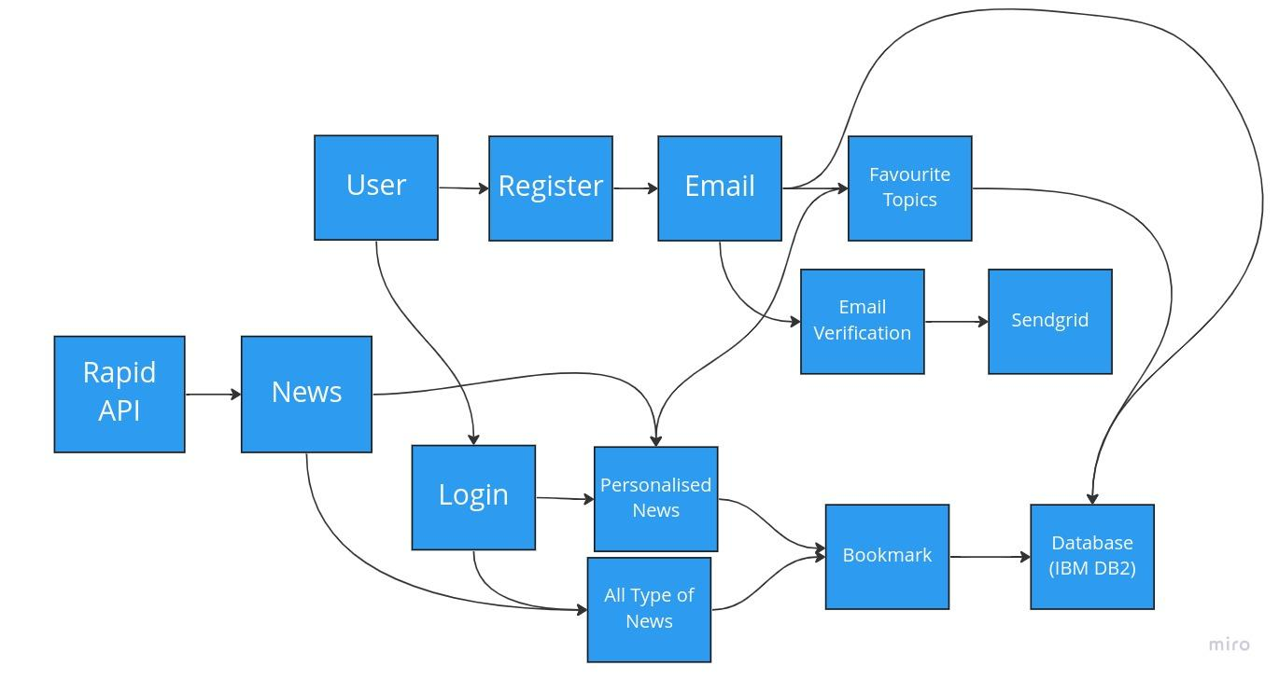

**User Stories**

Use the below template to list all the user stories for the product.

| **User Type** | **Functional Requirement (Epic)** | **User Story Number** | **User Story / Task** | **Acceptance criteria** | **Priority** | **Release** |
| --- | --- | --- | --- | --- | --- | --- |
| Normal User | Registration | USN-1 | As a user, I can register for the application by entering my email, password, and confirming my password. | I can access my account / dashboard | High | Sprint-1 |
|  | Email Verification | USN-2 | As a user, I will receive confirmation email once I have registered for the application | I can receive confirmation email & click confirm | High | Sprint-1 |
|  | Favourite topics | USN-3 | As a user, I can choose my favourite topics | I can see all my preferred news under for you category | Medium | Sprint-2 |
|  | Login | USN-4 | As a user, I can login with the email and password into the app | I can access to all the news | High | Sprint-1 |
|  | Dashboard | USN-5 | As a user, I can see all the news under specific tab | I can view all the news | Medium | Sprint-3 |
|  | Bookmark | USN-6 | As a user, I can bookmark my favourite news topics | I can later view my bookmarked news | Low | Sprint-2 |
|  | Access | USN-7 | As a user, I can access the site anywhere and everywhere | I can view the site by typing the URL of the site | High | Sprint-4 |
|  |  |  |  |  |  |  |
|  |  |  |  |  |  |  |
|  |  |  |  |  |  |  |
|  |  |  |  |  |  |  |
|  |  |  |  |  |  |  |